Experiment 1
Title
Design and Implementation of a Library Management System using SQL

Aim of the Session
To design and implement a Library Management System using SQL by creating relational database tables with appropriate constraints and performing data manipulation and data control operations to manage and secure library data efficiently.

Objective of the Session
- Understand database design for real-world applications
- Create tables using primary keys and foreign keys
- Maintain data integrity using constraints
- Perform DML operations such as INSERT, UPDATE, and DELETE
- Implement database security using roles and privileges (DCL)

Practical / Experiment Steps
- Create tables for Books, Members, and Book_Issue
- Define Primary Key and Foreign Key constraints
- Insert sample records into the tables
- Perform UPDATE and DELETE operations
- Create a role named Librarian
- Grant and revoke permissions using role-based access control
- Verify results using SELECT queries

Procedure of the Experiment
- Start the system and log in to the computer.
- Open the PostgreSQL environment using pgAdmin.
- Create or select the required database.
- Write SQL commands to create tables with appropriate constraints.
- Insert records into tables using INSERT statements.
- Execute UPDATE commands to modify existing records.
- Execute DELETE commands to remove records safely.
- Create a role named Librarian with login privileges.
- Grant SELECT, INSERT, and DELETE permissions to the role.
- Revoke permissions to test role-based access control.
- Execute SELECT queries to verify correctness of data.
- Save the work and take screenshots for record.

I/O Analysis (Input / Output Analysis)
Input Provided
- SQL commands for:
  - Creating tables (Books, Members, Book_Issue)
  - Defining primary key and foreign key constraints
  - Inserting sample records
  - UPDATE and DELETE operations
  - Role creation and privilege management
Output Generated
- Tables created successfully with constraints
- Records inserted and displayed correctly
- Member and book details updated successfully
- Records deleted while maintaining referential integrity
- Librarian role created successfully
- Permissions granted and revoked correctly

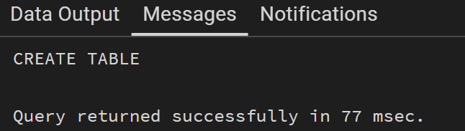
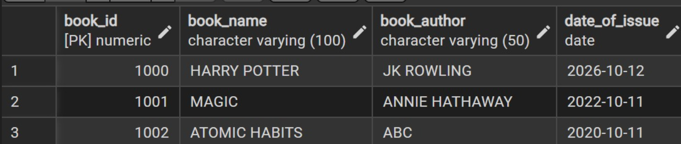
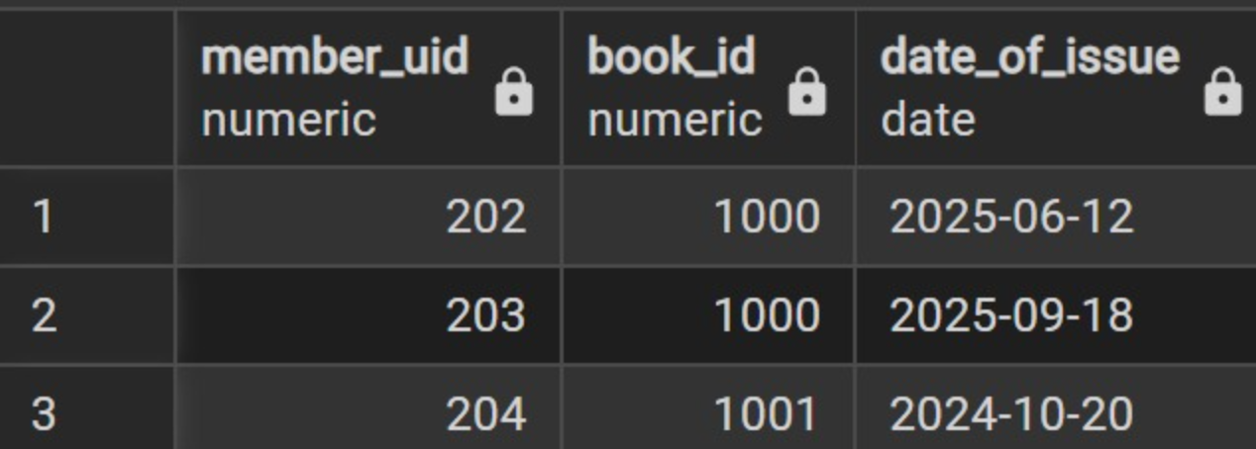

Learning Outcome
From this practical I learnt:
- How to design a relational database schema
- Usage of primary keys and foreign keys
- Importance of data integrity and constraints
- Execution of DML operations (INSERT, UPDATE, DELETE)
- Implementation of role-based database security using DCL commands
- Hands-on experience with PostgreSQL database management

